# ECE105 Midterm

## Thursday Group work portion (worth 15% of the total midterm grade)

1. A car rounding a banked curve has a coefficient of friction, μ. Which of the following is true:
   1. There is a maximum speed the car can have, after which it will begin to slide
   2. There is both a minimum and maximum speed the car can have without slipping.
   3. There is a minimum speed the car can have, after which it will begin to slide
   4. There is only one possible speed for the car to make the curve without slipping
2. 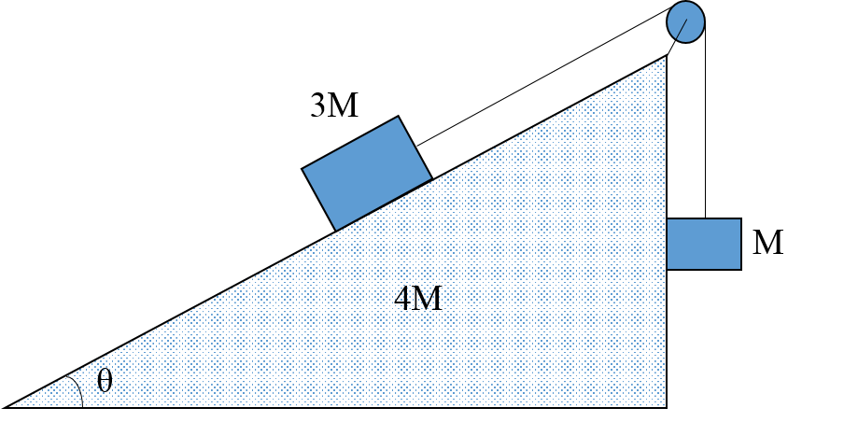In this frictionless mass-pulley system, a horizontal force F is applied to the mass on the incline, so that the hanging mass M does not move up or down. Which is the correct free body diagram for the hanging mass M?

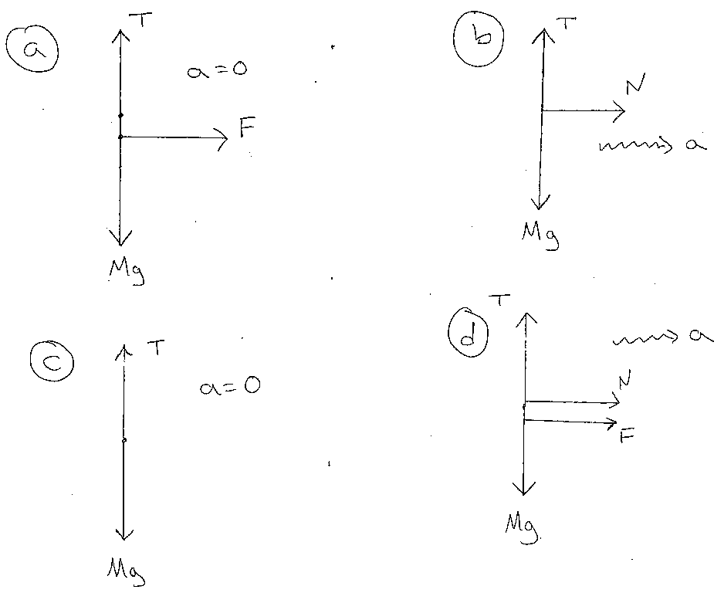

1. In the system shown, in what direction does the frictional force act on M, if the block M does not slide on m?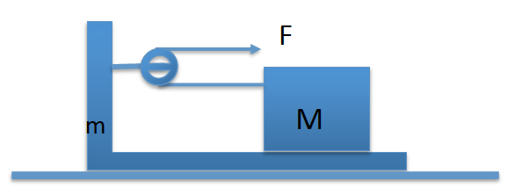
   1. Left
   2. Impossible to tell
   3. There is no friction
   4. Right
2. Why can gravity usually be neglected during a vertical inelatic collision between a bullet and a block, like the midterm problem? 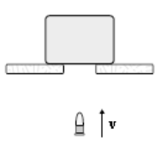
   1. It can’t be neglected without introducing significant error (>10%)
   2. The impulse due to gravity is small
   3. The force due to gravity is small relative to the net force on the block.
   4. Gravity does not act during the collision
3. A stunt plane dives at 20 degrees below the horizontal, moving at a speed of 210 km /hr. It is headed straight for an air balloon, standing still in the air 200 m away at an altitude of 4km. Two stunt people jump out at the same time: A jumps out of the plane and B out of the balloon. Assume they have zero initial velocity relative to the objects they jump out of.
   1. It depends on how the 200m distance is measured
   2. A will pass above B
   3. A will pass below B
   4. A will collide with B